Project ID : 9

Software Requirements Specification

for

Augmented Reality Based Text To 3D Visualizer For Kindergarten Students

Version 1.0

Prepared by

Group Name: SOFTcodein

|  |  |  |
| --- | --- | --- |
| ANUM KHAN | CS-002 | anumkhan2910@gmail.com |
| MAHAM ARIF | CS-003 | mahamarif49@gmail.com |
| SAYYADA SHAAMA HASSAN KAZMI | CS-004 | Shaamahassan@gmail.com |

|  |  |
| --- | --- |
|  |  |
|  |  |
| Internal: | MISS MARIA WAQAS |
| Co-Internal: | SIR ALI AKHTAR |
| Date: | 24th January, 2017 |

Contents

1 Introduction 1

1.1 Document Purpose 1

1.2 Product Scope 1

1.3 Intended Audience and Document Overview 2

1.4 Definitions, Acronyms and Abbreviations 2

1.5 Document Conventions 4

1.6 References and Acknowledgments 4

2 Overall Description 5

2.1 Product Perspective 5

2.2 Product Functionality 5

2.3 Users and Characteristics 6

2.4 Operating Environment 7

2.5 Design and Implementation Constraints 7

2.6 User Documentation 7

2.7 Assumptions and Dependencies 8

3 Specific Requirements 9

3.1 External Interface Requirements 9

3.2 Functional Requirements 10

3.3 Behaviour Requirements 11

4 Other Non-functional Requirements 13

4.1 Performance Requirements 13

4.2 Safety and Security Requirements 13

4.3 Software Quality Attributes 13

5 Other Requirements 14

Appendix A – Data Dictionary 14

# 

# Introduction

The current section of the Software Requirement Specification (SRS) document is to provide the overview of the project Augmented Reality based Text to 3D Visualizer for Kindergarten Students with the help of background studies and technological explainations, and scope of the project and the end product.

The Augmented Reality based Text to 3D Visualizer for Kindergarten Students is a project aimed at creating a better learning environment for Kindergarteners by using technology. The end product is an android application which will be able to create a visual representation of input sentences to aid for better understanding and learning.

## Document Purpose

The purpose of this document is to create a better understanding of the rationale behind the project “Augmented Reality based Text to 3D Visualizer for Kindergarten Students” along with the requirements that have been drawn to provide the best service to the end user. This document will also provide a conceptual overview of the technological aspects of the project that have been considered as relevant in the initial phase as well as the other features that will come to light as the project develops.

This document sketches out the technological and conceptual characteristics of the system and lays out the functionalities that are to be provided along with the constraints that may act on the system.

## Product Scope

### Description

This 3D visualizer application is basically an android AR app which will provide visual representation, using 3D objects and Augmented Reality, of normal sentences that are part of the curriculum of kindergarten students. The app will also have different poems and other interative functionalities to keep the young students engaged in learning.

### Benefits

According to a scientific study, visual learning helps in knowledge retention, improves reading comprehension, enhances achievement capabilities of students and develops critical thinking [1]. The AR app will thus provide 3D representation of different objects to aid kindergarten students in understanding meaning of sentences and helping them in learning names of objects.

### Goals

The basic purpose of the project is to promote the habit of concept based learning at a very early age to improve the education standards of Pakistan. The different poems and activities in the app will help to keep the interest of kindergarteners towards education.

## Intended Audience and Document Overview

The intended readers for this SRS document will be the project developers, testers and the professors. The schools and parents who are interested in purchasing or using this software will also be able to review this document.

The document is further organized as follows:

* Section 2 explains different aspects and functionalities of the project. It describes various constraints in operating environment of the app as well as the assumed dependencies.
* Section 3 provides a detailed description of the complete requirements of the project that have been laid out to meet the needs of the end user of the application. It also presents complete specification of the product as well as resources identification intended for the developers and supervisers of the project.
* Section 4 provides description of other non functional requirements that effect the performance of the project.

## Definitions, Acronyms and Abbreviations

* **Assets:** An asset is representation of any item that can be used in a game or project. An asset may come from a file created outside of Unity, such as a 3D model, an audio file, an image, or any of the other types of file that Unity supports.
* **3D Graphics:** 3D stands for three dimensional. 3D graphics is the creation, display and manipulation of objects in the computer in three dimensions. 3D graphics programs allow objects to be created on an X-Y-Z scale (width, height, depth). [2]
* **3D Modeling:** 3D modeling is the process of creating a three dimensional representation of any surface or object by manipulating polygons, edges, and vertices in simulated 3D space via specialized 3D production software. [3]
* **Blender:** Blender is the free and open source 3D creation suite. It supports the entirety of the 3D pipeline—modeling, rigging, animation, simulation, rendering, compositing and motion tracking, even video editing and game creation. [4]
* **Database:** A structured set of data held in a computer, especially one that is accessible in various ways.
* **Game Object:** A game object is any object in a game that the player can see and/or interact with. The player object, power ups, enemies, platforms, walls, weapons, etc are all game objects. GameObjects don’t do anything on their own. They are the container of different components which bring functionalities to them.
* **Augmented Reality:** It is the rendering of 3D computer graphics in the real world with the help of sensory information on the device to provide a realistic experience.
* **NLP:** It stands for “Natural Language Processing” which is a field of Computer Science and Artificial Intelligence that is aimed at the analyzation and understanding of human languages to improve the interaction between humans and computers.
* **Project:** A collection of related models, each stored in a separate file.
* **Rendering:** Rendering is the process of generating an image from a 2D or 3D model (or models which can collectively be called as a scene file) by means of application programs. [5]
* **Scene:** Each app on Unity is divided up into several scenes. A scene is defined by a change in the background image. Scene contains objects of the application or game.
* **Splash Screen:** It is the first screen appears to user when application launches.
* **SQLite:** SQL stands for Structured Query Language. SQLite is an in-process library that implements a self-contained, serverless, zeroconfiguration, transactional SQL database engine.
* **UI:** User Interface
* **UML:** UML stands for Unified Modelling Language.
* **Unity:** Unity is a powerful cross-platform game engine and a user friendly development environment. It is easy enough for the beginner and powerful enough for the expert; Unity provides easy creation of 2D and 3D games and applications for mobile, desktop, the web, and consoles.
* **Use Case View:** A use case diagram is a graphic depiction of the interactions among the elements of a system.
* **User:** The person using or interacting with the application.
* **Python:** Python is a high-level computer language that is used for development purposes.
* **Spyder:** Spyder is a powerful and interactive python IDE which provides advance features and is used for Scientific development and Artificial Intelligence.
* **Django:** Django is Python Web Framework that is used to provide ease of development for web applications.
* **Web Framework :** A Web Framework is a piece of software that provides advanced features that make Web Development easier by means of additional services and resources.
* **App**: Mobile Application
* **AR**: Augmented Reality

## Document Conventions

This document follows the IEEE standard format. Font style for the content in the document is Times New Roman. Font size for headings is 20, for subheadings 16 and for rest of the content font size is 12. All headings are in bold form. Document text is 1.15 spaced.

UML Diagram used is the Use case view description of the project which is prepared on UML online software GLIFFY.

The document is designed using Microsoft Word 2010 (MS Word).

## References and Acknowledgments

[1] Study. “Graphic Organizers: A Review of Scientifically Based Research”,www. inspiration.com. [Online].

Available:

<http://www.inspiration.com/sites/default/files/documents/Detailed-Summary.pdf>.

[Accessed: Jan 17, 2018].

[2] PCMag.“Definition of 3D Graphics”,www.pcmag.com. [Online]. Available: <http://www.pcmag.com/encyclopedia/term/37072/3d-graphics>. [Accessed: Jan. 17, 2018].

[3] Lifewire.“What is 3D Modeling?”,www.lifewire.com. [Online]. Available: <https://www.lifewire.com/what-is-3d-modeling-2164>. [Accessed: Jan. 17, 2018].

[4] Blender.“About”,www.blender.org. [Online]. Available: <https://www.blender.org/about/>. [Accessed: Jan. 17, 2018]

[5] Wikipedia.”Rendering (computer graphics)”,en.wikipedia.org. [Online]. Available: <https://en.wikipedia.org/wiki/Rendering_(computer_graphics)>. [Accessed: Jan. 17, 2018].

# Overall Description

## Product Perspective

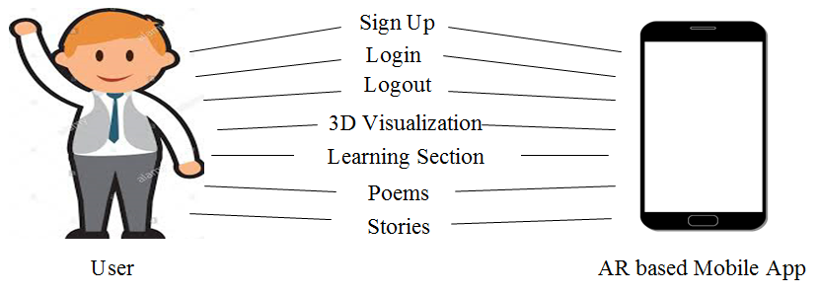The current era is the era of technology and the use of cellphones and tablets for learning is the new trend among the young generation. Thus the perspective of this mobile application is to create a healthy learning environment for kindergarten students. Through this application the students can experience or visualize in a 3D space the words or sentences they want to learn or understand which help them to learn and understand quickly. This product may also help children suffering from dyslexia to overcome their learning problem through 3D visualization. This application will facilitate parents to teach their children at home.

## Product Functionality

### 2.2.1 Sign Up

The user can start using the app by creating an account so that all the history of what he or she ever typed and all other user details will be saved. Player has to provide his/her name, email address and password to create his/her account or he or she can sign up using google or facebook account.

**2.2.2 Login**

User can login to the app using his or her email address and password, provided that he or she has created a user account using sign up procedure before.

**2.2.3 Logout**

User will also have an option to logout of the app.

**2.2.4 3D Visualization**

The user has an option to type in a word or sentence he or she want to learn or understand. The application identify the objects in the input sentence and place those objects virtually in the 3D space or environment through augmented reality which will convey the meaning of that sentence.

**2.2.5 Learning Section**

In Learning Section of the app the user will be able to select different categories of objects to view different objects in the 3D space. For example, if user select the category of animals, he or she will be able to see different animals in a 3D environment.

**2.2.6 Poems and Stories**

The user will have an option to view different poems and stories in a 3D environment by selecting the category of poems and stories in the app.

## Users and Characteristics

This software product can be used by anyone who has primary knowledge of android platforms such as mobile phones, tablets etc. This mobile app will target students from kindergarten to help them building a strong foundation of knowledge, to facilitate them in their studies and to enhance their learning capabilities. This product may also help children suffering from dyslexia to overcome their learning problem through 3D visualization. This application will facilitate parents to teach their children at home. The beneficiaries of this product are:

**2.3.1 Kindergarten Students**

Through this application the students or children can experience or visualize in a 3D space the words or sentences they want to learn or understand which help them to learn and understand quickly.

**2.3.2 Parents and Kindergarten Teachers**

This product can be used by parents who are not literate enough to teach their children to ensure better learning of their children through this application. This application may also help teachers in improving the learning of their students.

**2.3.3 Children suffering from Dyslexia**

This application will be useful for students who face difficulty in visualization, for example, the children suffering from dyslexia. This application will help those students in effective learning.

## Operating Environment

The operating environment of this android application involves following two essentials :

### Software:

* Android operating system 7.0 or later is required.
* **Hardware**:
* A smart phone or tablet with an android platform.

## Design and Implementation Constraints

**2.5.1 Cost Issues**

To develop this text to graphics converter application, a lot of 3D models are required, only some of them are available for free. Other models are very expensive.

**2.5.2 Timing Requirements**

App development requires a lot of hardwork other than coding, which includes further scene and 3D objects creation. This requires a sufficient amount of time.

**2.5.3 Memory Requirements**

The tools required for the application development (unity3d, blender etc) consume huge memory.

**2.5.4 Tools Limitation**

Blender is the only 3D modeling tool which is available for free.

## User Documentation

Not Applicable in our Project.

## Assumptions and Dependencies

**2.7.1 Assumptions**

It is assumed that all users have an android device without any internet connectivity or other issues.

**2.7.2 Dependencies**

This project is a tool dependent project. It can only be developed using Unity3D game engine, and the only tool available for 3D modeling is Blender because it is free of cost. Other tools for 3D modeling are very expensive.

# Specific Requirements

## External Interface Requirements

### User Interfaces

**Splash Screen Login Options Screen**

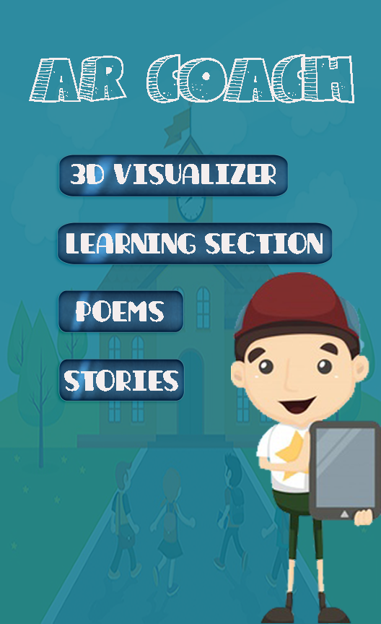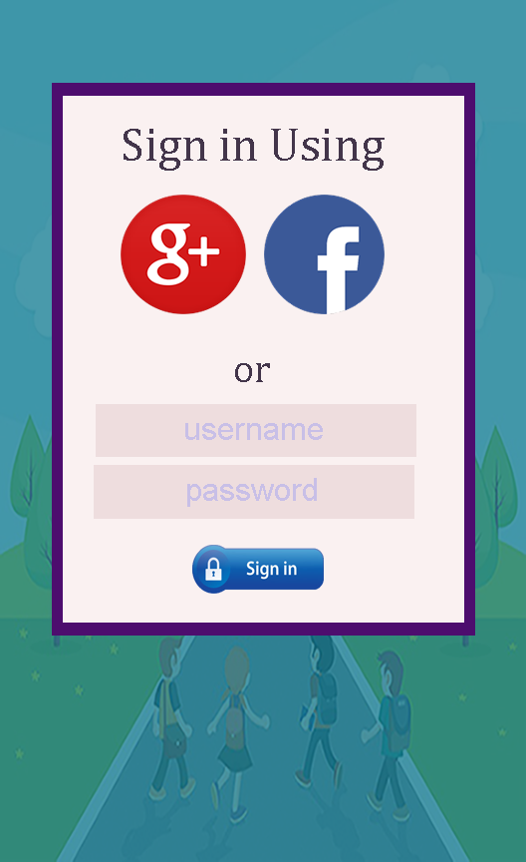****

**UI SCREENS FLOW**

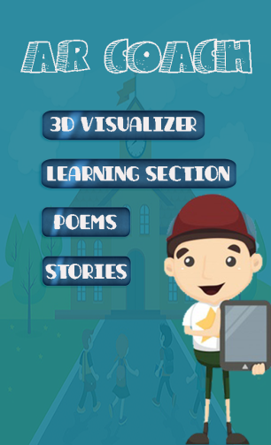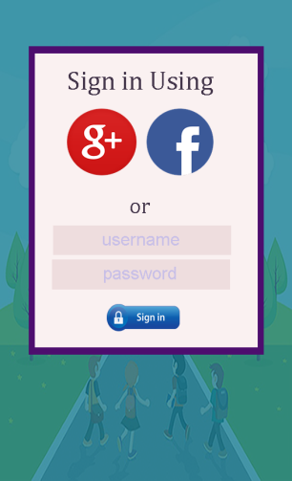

**Splash Screen Login Options Screen**

### Hardware Interfaces

Not Applicable in our Project.

### Software Interfaces

This application demands android platform with operation system 7.0 or later installed in an android smart phone.

### Communications Interfaces

This android application is dependent on Wifi or internet for its operation.

## Functional Requirements

|  |  |
| --- | --- |
| **Function 1** | **Sign Up** |
| Input | Full Name, Email Id and Password |
| Output | Options Screen of the application is displayed. |
| Processing | Validates Email Id, and adds the new user record in the database. |

|  |  |
| --- | --- |
| **Function 2** | **Login** |
| Input | Email Id and Password |
| Output | Options Screen of the application is displayed. |
| Processing | Validates Email Id and Password from the database. |

|  |  |
| --- | --- |
| **Function 3** | **Log Out** |
| Input | Click on the Log out button |
| Output | Login screen of the app is displayed. |

|  |  |
| --- | --- |
| **Function 4** | **3D Visualization** |
| Input | A word or sentence which can be visualized |
| Output | Display of objects virtually in the 3D space or environment through augmented reality which will convey the meaning of the input sentence. |
| Processing | 3D models are retrieved from the server based on the phrases extracted from the input and placed in the environment through augmented reality. |

|  |  |
| --- | --- |
| **Function 5** | **Learning Section** |
| Input | Click on any of the categories of objects (for example plants, animals, etc) in the Learning Section of app. |
| Output | Display of the relevant objects in the 3D environment. |
| Processing | 3D models are retrieved from the server based on the phrases extracted from the input and placed in the environment through augmented reality. |

|  |  |
| --- | --- |
| **Function 6** | **Poems and Stories** |
| Input | Click on the Poems and Stories category in options screen. |
| Output | Displays sub categories and on click on any sub category (a poem or a story), 3D objects are displayed time to time just like a 3D video for the specific poem or story. |
| Processing | 3D models are retrieved on the basis of selection of a particular poem or story and displayed in the 3D environment through augmented reality. |

## Behaviour Requirements

### Use Case View

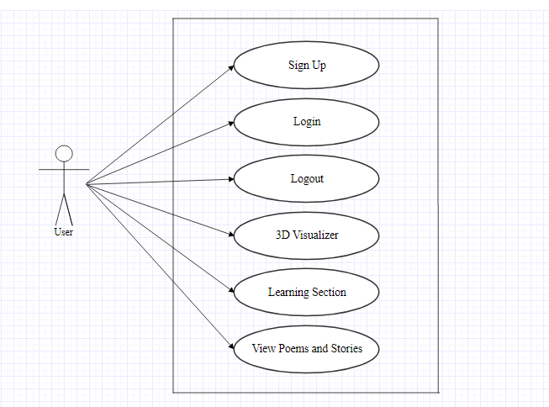

**Use Case Diagram**

|  |  |
| --- | --- |
| **Actor** | **Description** |
| User | A person who will use the app or the person who interact with the app (i.e. a child, a teacher or parents). |

|  |  |
| --- | --- |
| **Use Case** | **Description** |
| Sign Up | This use case provides the capability for a user to create a new account using an email id or password or through google or facebook to use the app. |
| Login | This use case provides the capability for a user to login to the app using his or her email id and password. |
| Logout | This use case provides the capability for a user to loogout from the app. |
| 3D Visualizer | This use case provides the capability for a user to enter a word or a sentence which he or she wants to learn or visualize and view different objects in the 3D space which will convey the meaning of sentence. |
| Learning Section | This use case provides the capability for a user to select different categories of objects in the learning section of the app to view in the 3D space. |
| View Poems and Stories | This use case provides the capability for a user to select any poem or story and view different objects in the 3D space which are displayed from time to time just like a 3D video for the specific poem or story. |

# Other Non-functional Requirements

## Performance Requirements

Performance requirements define acceptable response times for system functionality. The application performance depends upon the quality of device used and the internet speed.

Following are the performance requirements for the AR based Android Application:

* User sign up or login should not take more than 5 seconds.
* On starting the application, it should be started or loaded within 10 seconds.
* The application should be interactive and user friendly.
* The response of the application to the user input should be within milliseconds.
* On entering any sentence or on clicking any category, the result should be displayed within 10 seconds provided there is no internet connectivity issue.

## Safety and Security Requirements

There are no critical safety or security requirements for the application however there may be arises the requirement of database integrity which is as follows :

* **Database Security**

The history for the user and other information such as account information should not be lost.

## Software Quality Attributes

**4.3.1 Reliability**

Reliability is the ability of a software to perform its intended functions and operations in a system’s environment, without experiencing failure (system crash). This application will be made reliable through efficient coding techniques. It will run smoothly without any failure.

**4.3.2 Efficiency**

Efficiency of the application is how fast it responds to user inputs and how less power it consumes. This application will be fast and can be used well on a device with less battery power.

**4.3.3 Usability**

How easily a person can be taking the benefits of the software through its user friendliness. The application will be user friendly.

**4.3.4 Integrity**

Integrity is how the system would secure the information in the system and how it avoids the data losses. The history and account information of the User will remain saved in the application.

**4.3.5 Correctness**

Correctness means extent to which program satisfies specifications, fulfills user mission objectives. The application will meet the requirement of correctness in the sense that it will display 3D objects in the way that convey the meaning of the input sentence.

**4.3.6 Maintainability**

Maintainability is how easy it is to keep the software as it is and correct defects with making changes. The application will be designed in a specific way so that it will be maintainable.

**4.3.7 Flexibility**

Ability to add new features to the software and handle them conveniently. The application will be flexible in a way that extra features such as new categories, new poems or stories and different small games for children can be added to it to make it more interesting.

# Other Requirements

## Database Requirement

An online database will be created on hosting for the 3D models storage and for the Django Web Application containing the code for NLP Module.

Appendix A – Data Dictionary

|  |  |  |  |
| --- | --- | --- | --- |
| **TDModels** | | | |
| **Field Name** | **Data Type** | **Constraints** | **Sample Data** |
| Model_Name | CharField(max_length=250) | Primary Key | Car |
| Category | CharField(max_length=250) | Not Null | Vehicles |
| Model_Image | CharField(max_length=1000) | Allow Null | - |
| Model_Url | CharField(max_length=1000) | Not Null | https://drive.google.com/open?id=17u3wUsX_rxsFj5obFLggNlhi2G9LWa-w |